Kindergarten News
October 2018
Here is what we will be working on this month in kindergarten:
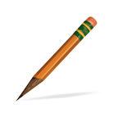  Writing Workshop  - Developing ideas  - Writing about events and experiences  - Labeling our pictures  - Stretching words and listening to sounds letters make  - Fixing our writing and adding details | Science & Social Studies  - - Identify types of weather  - - Describe the water cycle  - - Identify the 4 seasons  - - Name and identify U.S. Symbols  - - Name some important U.S. Leaders
Language Arts  - Understanding characters and setting.  - -Identifying the role of the author and illustrator in literary and informational text.  - Identify the front, back cover, title and title page in a book.  - Answer questions about key details in a book.  - Naming all letters and sounds  - Reading AND writing the 44 sight words | 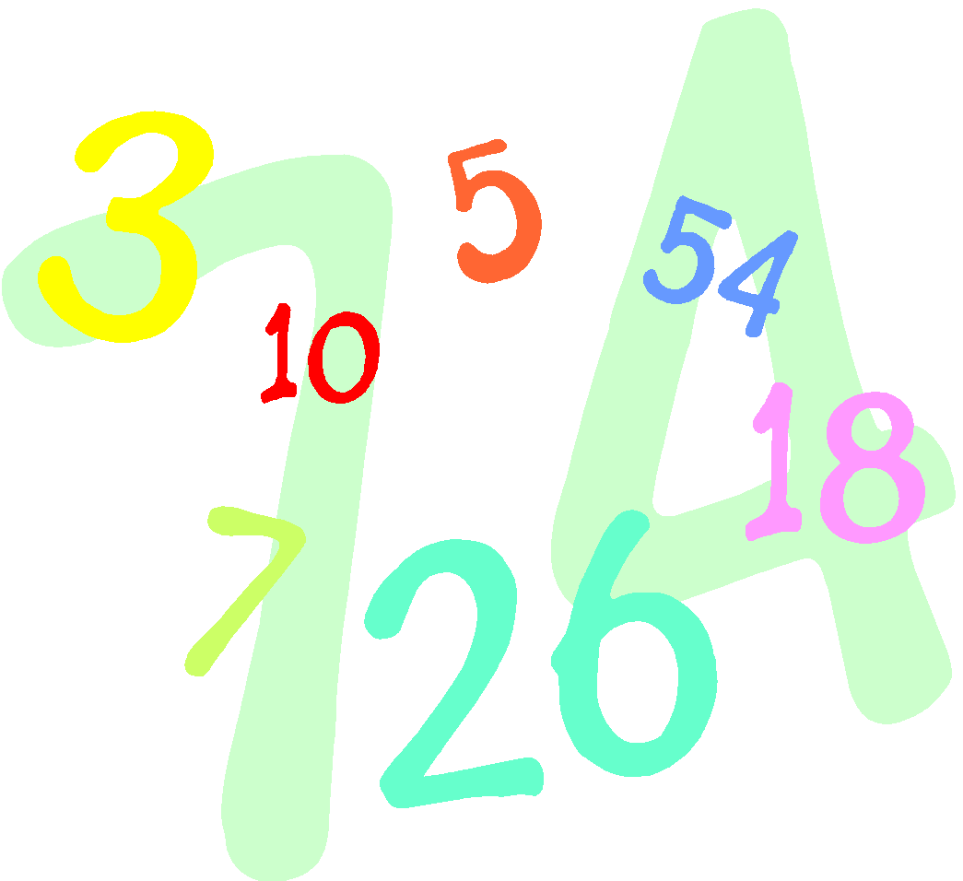  Math  - Count to 20 by 1’s  - Counting sets of objects  - Understanding and identifying a number that is one more and one less  - Compare height and length using more and less  - Writing numbers 1-10
Things to do at Home  - Complete the homework calendar activity each day  - READ and fill in your reading log  - Practice reading the Kindergarten words  - Practice tying your shoes and zipping your jackets | Important Dates  - ½ day—October 6th  - Open House (9:30-2:30)—October 9th  - Parent Meeting (9:30)—October 13th  - Picture Day—October 19th  - PTA Movie Night—October 20th  - Reading Night—October 25th  - Halloween Parade (2:00)—October 27th  - Field Trip—October 31st
Reminders

Change of Clothes - Please be sure to send in shirts and pants and underwear for your child’s extra clothes bag at school! ☺
Folders – Please check you child’s folder EVERY night!!

