Kindergarten News
November 2018
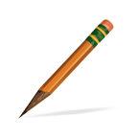  Writing Workshop  - Developing ideas  - Using strategies to sound out words  - Writing about events and experiences  - Writing an informational text | Science & Social Studies  - Seasonal Changes  - Seeds  - Identifying the basic needs of plants  - Identifying the life cycle of a plant  - Use model of the earth (globe)  - Physical features: landforms, bodies of water  - Physical and human made features in the world
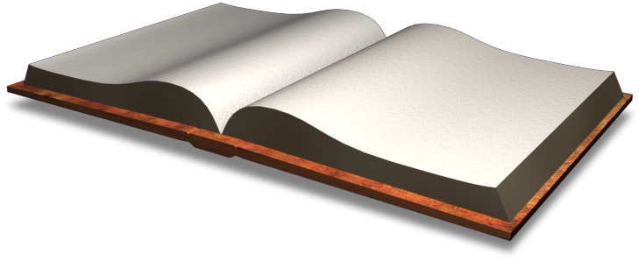  Language Arts  - Retelling familiar stories with beginning, middle, and end.  - Using key details to recall information from a story.  - Identifying the role of the author and illustrator in literary and informational text.  - Using before reading strategies  - Naming all letters and sounds  - Reading AND writing the 31 sight words | 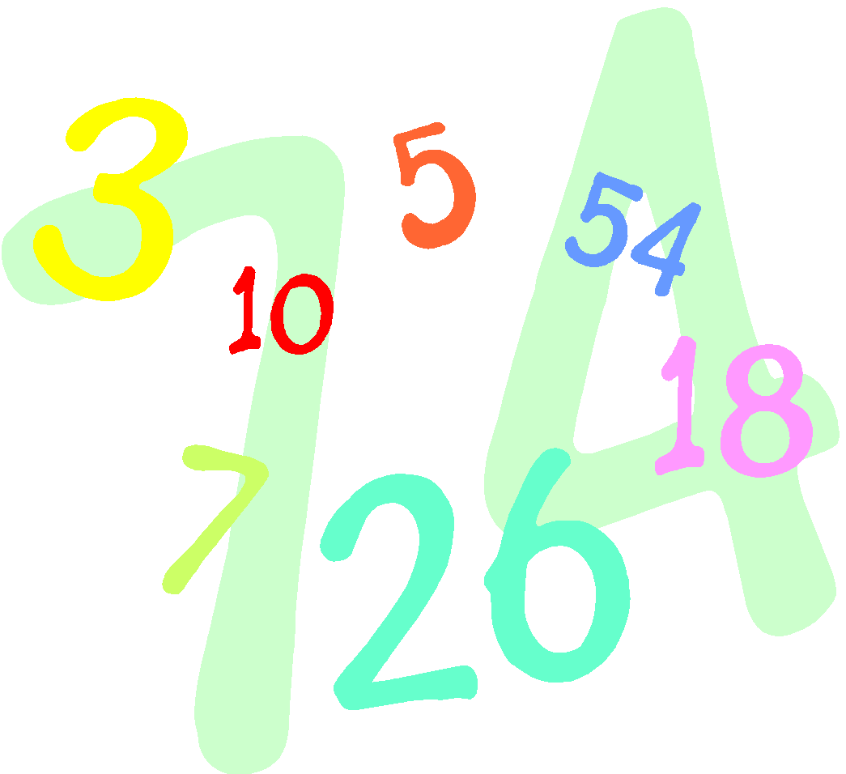  Math  - Count to 100 by 1’s  - Count to 100 by 10’s  - Describe and compare lengths or quantities  - Comparing and ordering quantities  - One more and one less  - Count sets of objects in different configurations
Things to do at Home  - Complete the homework calendar activity each day  - READ and fill in your reading log  - Practice reading the Kindergarten words  - Practice tying your shoes and zipping your jackets | Important Dates  - Nov. 6-10- PTA Book fair at Cresthaven  - Nov. 9- Early Release Day/End of 1st marking period  - Nov. 10- Early Release Day/Parent Teacher Conferences  - Nov. 16- Family Math Night  - Nov. 17- Early Release Day/Parent Teacher Conferences, PTA Turkey Bingo at Cresthaven  - Nov.22- Early Release day/Report Cards sent home  - Nov. 23/24- No school: Thanksgiving Break  - Nov. 29- Picture Day make ups
Reminders
Change of Clothes - Please be sure to send in long-sleeved shirts and pants for your child’s extra clothes bag at school. Many students still have shorts in their cubbies. We don’t want anyone getting sick! ☺
Here is what we will be working on this month in kindergarten:

