Kindergarten News
January 2018
Here is what we will be working on this month in kindergarten:
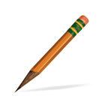  Writing Workshop  - Use drawings, dictating and writing to supply information on a topic.  - Respond to peers’ questions and suggestions to strengthen their writing.  - Identify end punctuation marks.  - Write letters for consonant and short vowel sounds. | Science & Social Studies  - Discuss safety and injury prevention.  - Identify similarities and differences between animals and their babies.  - Identify and describe animals that undergo metamorphosis.  - Identify and describe changes in the human life cycle.  - Describe how people adapt and modify their environment.  - Identify and describe how maps and globes can help people.
Language Arts  - Explore words (antonyms, verbs, adjectives, words specific to topic).  - Review directionality, spacing and letters.  - Ask and answer questions about a specific topic, state key details and identify unknown words. | 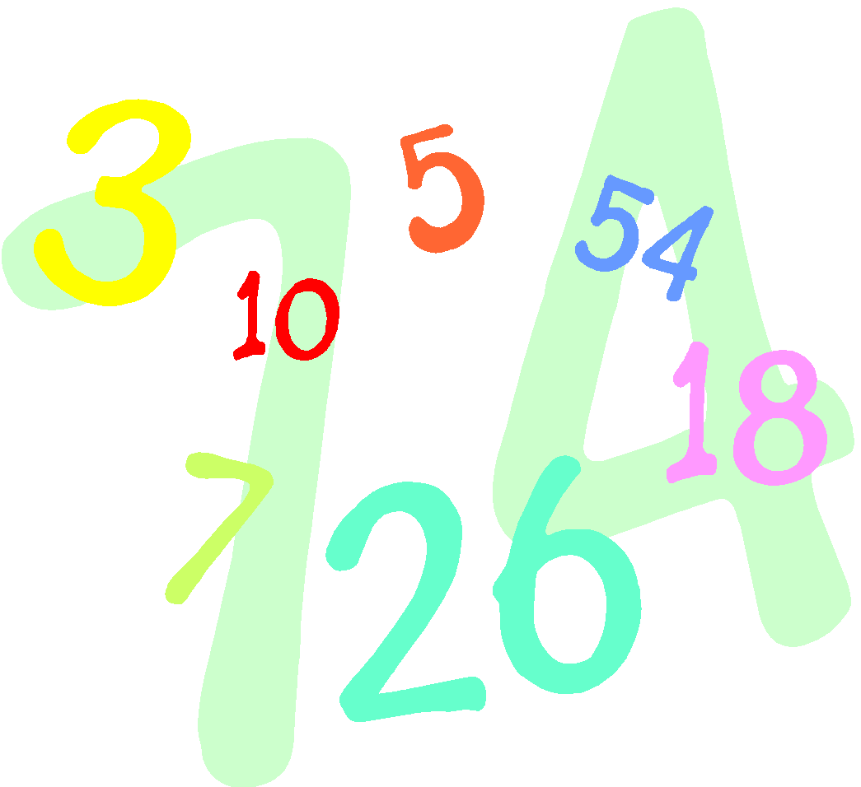  Math  - Count to 100 by 1’s and 10’s.  - Represent and solve +/- word problems within 10.  - Decompose numbers less than or equal to into pairs in more than one way.  - Write numbers 0 – 20.  - Understand relationship between numbers and quantities.
Things to do at Home  - Complete the homework calendar activity each day  - Read and fill in your reading log  - Practice reading the kindergarten words  - Practice tying your shoes, zipping your jackets and washing hands after blowing their noses. | Important Dates  - Jan. 12th ~ Parent Mtg @ 9:30  - Jan. 15th ~ No School  - Jan. 25th ~ Early Release Day  - Jan. 26th ~ No School for Students
Reminders

Change of Clothes - Please be sure to send in long-sleeved shirts and pants/skirts for your child’s extra clothes bag at school. Many students still have summer clothes in their cubbies.

