Kindergarten News
February 2018
Here is what we will be working on this month in kindergarten:
Writing Workshop  - Narrate an event or events in order  - Respond to peers’ questions and suggestions to strengthen their writing.  - Identify end punctuation marks.  - Write letters for consonant and short vowel sounds.  - Name a topic and supply information about that topic. | Science & Social Studies  - Identify the food groups and healthy eating  - Identify external features of animals and basic needs for survival.  - Identify animals that live here in Maryland.  - Identify some of our Natural Resources  - Goods and Services.
Language Arts  - Retelling stories and parts of stories, such as Beginning, Middle, End, Setting, and Characters.  - Finding unknown words and strategies to figure them out.  - Ask and answer questions about a specific topic, state key details and identify unknown words. | 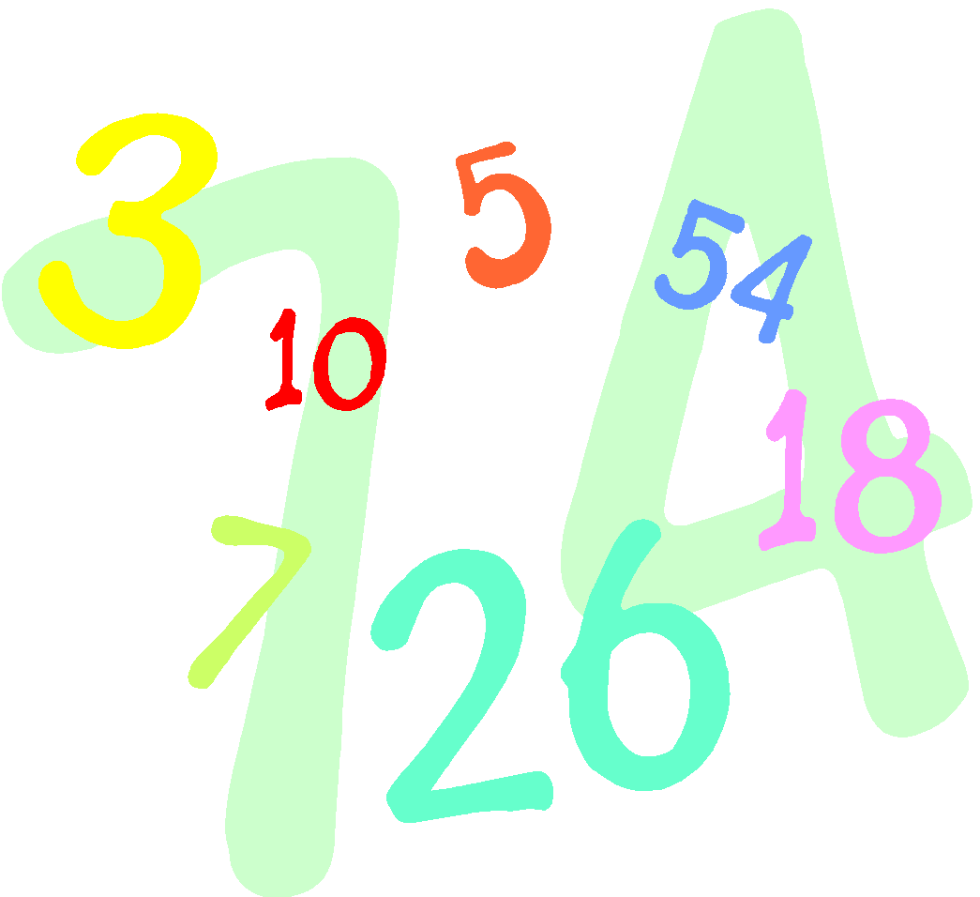  Math  - Count to 100 by 1’s and 10’s.  - Become fluent in decomposing numbers to 5, for example, 1 and 4, or 3 and 2  - Identify and make 2 Dimensional Shapes (Flat Shapes), Square, Rectangle, Triangle, Circle and Hexagon  - Identify and describe 3 Dimensional shapes too  - Write numbers 0 – 20.
Things to do at Home  - Complete the homework calendar activity each evening  - Practice reading and writing the Kindergarten words.  - Practice tying your shoes, zipping your jackets and washing hands after blowing their noses.  - Draw and Color! It makes your finger muscles stronger! | Important Dates  - Feb 8th - Report Cards sent home  - Feb 8th - 100th day of school  - Feb 14th - Friendship Day Parties  - Feb 19th - NO SCHOOL  - Feb 23rd - Parent Meeting @ 9:30
Reminders
Change of Clothes - Please be sure to send in long-sleeved shirts and pants/skirts for your child’s extra clothes bag at school. Many students still have summer clothes in their cubbies.
Dress for the weather! Even if we have indoor recess, your child needs a coat in case we go outside for emergencies, or Fire Drills!

