Kindergarten News
December 2018
Here is what we will be working on this month in kindergarten:
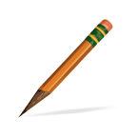  Writing Workshop  - Developing ideas  - Using strategies to sound out words  - Editing and fixing  - Writing about events and experiences and providing a reaction  - Writing an informational text | Science & Social Studies  - Identifying the basic needs of animals  - Identifying the characteristics of living things  - Observing how animals grow and change  - Matching animals and their babies  - Observing and describing natural and human-made features  - Identifying and understanding maps
Language Arts  - Retelling familiar stories with beginning, middle, and end.  - Using key details to recall information from a story.  - Identifying the role of the author and illustrator in literary and informational text.  - Using before reading strategies  - Naming all letters and sounds.  - Reading AND writing the 31 sight words | 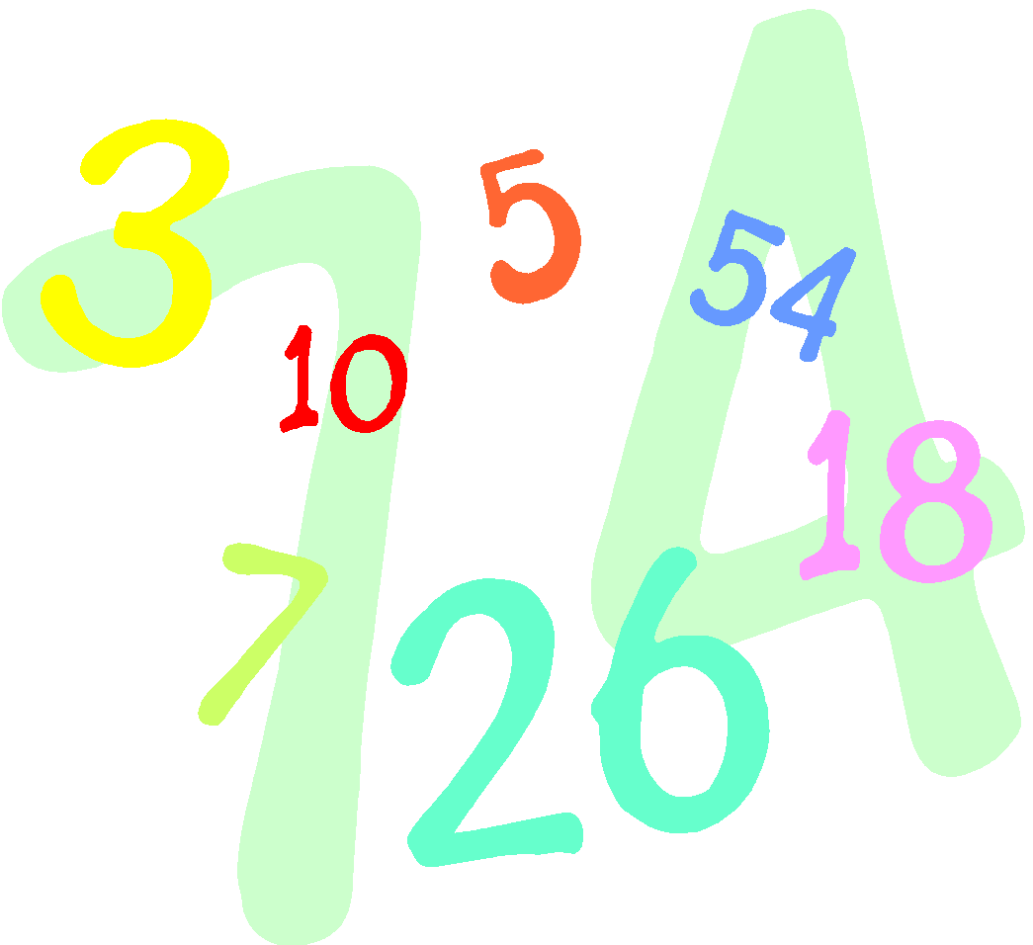  Math  - Count to 100 by 1’s  - Count to 100 by 10’s  - Understanding and identifying a number that is one more and one less  - Keeping track of a growing set of objects  - Counting forward from a number other than one  - Measuring and comparing the weight and length of objects
Things to do at Home  - Complete the homework calendar activity each day  - READ and fill in your reading log  - Practice reading the Kindergarten words  - Practice tying your shoes and zipping your jackets | Important Dates  - Dec 2.- Holiday Thrift Store 8:30-10:30am  - Dec. 8- Parent meeting 9:30am  - Dec. 22- Pajama Day  - Winter Break (December 25- January 1)
Reminders
Change of Clothes - Please be sure to send in long-sleeved shirts and pants for your child’s extra clothes bag at school. Many students still have shorts in their cubbies. We don’t want anyone getting sick!

